
programming for data analysis



Table of Contents
1 Introduction and Motivation of the Research Problem 3
2 Introduction to Data Handling 4
2.1 Data Import Process 4
2.2 Construction of the combined dataset 4
2.3 Missing Value Treatment and Data Cleaning 4
2.3.1 Eliminating Columns that Have Full Missing Values 5
2.3.2 Median Imputation of Numerical Variables 5
2.3.3 Mode Imputation of Categorical Variables 5
2.3.4 Date Conversion and Cleaning 5
2.3.5 Final Verification 5
3 Critical Assessment of Methodologies 5
3.1 Data Cleaning Techniques Evaluation 5
3.2 Descriptive Data Analysis (EDA) 6
3.2.1 Bar Chart 6
3.2.2 AQI Bucket Distribution (Doughnut Chart) 7
3.2.3 Time Series Trend of AQI by City 7
3.2.4 City-wise Distribution of Air Quality Buckets (Bar Chart) 8
3.2.5 Overall Average Pollutant Concentration (Bar Chart) 9
3.2.6 PM2.5 Distribution in Good vs Severe Air Quality 10
3.2.7 Correlation Heat-map for Numerical Pollutants 10
4. Evaluation of EDA 11
5. Model Implementation 11
6. Model Evaluation 12
7. Critical Reflection 13
8. Conclusion 13
9. References 15

List of Figures
Figure 1Average AQI per Bucket (Bar Chart 6
Figure 2 AQI Bucket Distribution (Doughnut Chart) 7
Figure 3Time Series Trend of AQI by City 8
Figure 4City-wise AQI Bucket Distribution 8
Figure 5Overall Average Pollutant Concentration 9
Figure 6 Distribution in Good vs Severe Air Quality 10
Figure 7 Correlation heat-map for all cities 11
Figure 8(KNN) Classification report 12
Figure 9(KNN) Model performance 12
Figure 10 Random Forest Classification Report 13
Figure 11Random Forest Model performance 13
Figure 12 XGBoost Clssification Report 14
Figure 13XGBoost Model Performance 14
Figure 14 Accuracy comparison 15
Figure 15Model Accuracy 16
Figure 16streamlit Model Prediction 16
Figure 17Streamlit Dashboard 17

1 Introduction and Motivation of the Research Problem
Air quality is now regarded as one of the paramount environmental and human health issues in the world, with urban centres growing at an extremely fast rate, experiencing dire situations in terms of pollution, emissions, industrialisation, and traffic. The pollution levels in India have kept on increasing over the last decade, which has resulted in severe growth in respiratory diseases, lower life expectancy, and increased environmental degradation. Cities like Delhi, Mumbai, Kolkata, and Gurugram often record Air Quality Index (AQI) that is much higher than the levels set by the global health standards as being safe. This is why it is so necessary to have credible data-driven methods to examine the trends of pollution, uncover patterns, build prediction capacities, and suggest evidence-based policies (5). The study will attempt to address the following research question on the basis of the thorough analysis of city-based pollutant concentrations and past AQI trends:
What is the pattern of pollutant concentration in the major cities in India, and how well can machine learning models correctly categorise AQI levels by pollutant concentration levels?
The following research question is applicable on various fronts:
- Environmental Significance: By knowing the factors behind poor air quality, specific measures can be taken to improve the situation through emission regulation, traffic control, and control of industries.
- Public Health Implications: AQI levels are linked to high respiratory and cardiovascular health outcomes. Early warnings can be served by predictive modelling.
- Urban Planning and Policy: The Urban Comparisons at the city level can be useful in steering the priority on the environmental policies and resources.
- Technological Relevance: Python-based analytics, machine learning algorithms, and visualisation tools are used, which are relevant to the current industry practices and academic requirements. The overall goal of this work is to use programming techniques in Python to import, clean, integrate, analyse, model, and visualise actual air quality information on ten of the largest cities in India.

2 Introduction to Data Handling
Ten CSV files that are included in this research hold the measurements of air quality of the cities of Delhi, Gurugram, Guwahati, Mumbai, Kolkata, Bhopal, Jaipur, Shillong, Thiruvananthapuram, and Amaravati. All the files have concentrations of pollutants, e.g., PM2.5, PM10, NO, NO 2, and NOx, NH 3, CO, SO 2, O 3, Benzene, Toluene, and Xylene, and the known Air Quality Index (AQI) and classification. The combination of these datasets provides a full basis for studying the spatial and temporal air quality change in India.

2.1 Data Import Process
First of all, the Colab environment was linked with Google Drive in order to retrieve the external CSV files. The data set of each city was then imported separately using a suitable data-loading function, taking care of the mixed data types. The datasets were loaded, after which they were sorted into a structured dictionary to enable systematic processing. The form (rows and columns) of every dataset was analyzed to ensure the successful import and to define any structural differences (5). To compile the data for analysis, the following step involves joining the digital and paper surveys into a single dataset, which will also include the focus group interviews and observations as well.

2.2 Construction of the combined dataset
To construct a dataset that should be analyzed, the next step will be to join the two surveys (digital and paper) and, additionally, the focus group interviews and observations.
Given that the study was conducted to conduct cross-city analysis and develop a unified machine learning model, all ten datasets were combined into a single dataset. This merger made the overall amount of usable observations much larger and allowed for a more meaningful comparative analysis (3). The combined dataset also gave an adequately high sample size to train classification models and enhance reliability and generalisability.

2.3 Missing Value Treatment and Data Cleaning
The records stored in the environmental data are often missing, erratic, or incorrect as a result of equipment malfunction, bad weather, or interruption in data collection. Hence, a formal cleaning procedure was necessary.

2.3.1 Eliminating Columns that Have Full Missing Values
There were columns where the data was not present in any rows, which were automatically detected and deleted. They were not particularly helpful as far as analysis is concerned, and keeping them within the dataset would only make it more complicated without providing any information (3).

2.3.2 Median Imputation of Numerical Variables
This was done by imputing numerical columns of pollutants with missing values, partly with the median. The reason why this method was selected is that pollutant data frequently have extreme outliers, and median imputation gives a more robust estimate of the data than the mean since it does not affect the underlying distribution.

2.3.3 Mode Imputation of Categorical Variables
In the column of the AQI category, any missing values were replaced by the most common category (mode). It is suitable to use this method with categorical data, and make sure that the imputed values are not in conflict with the overall class distribution of the data.

2.3.4 Date Conversion and Cleaning
The values of dates that were in the form of strings were then changed to standard datetime objects to allow time analysis. Records that had invalid or unrecognisable dates were eliminated to ensure accuracy in the process of temporal visualisation and trend analysis.

2.3.5 Final Verification
All cleaning procedures were followed, after which the dataset was reexamined to ensure that no values were missing (2). This guaranteed that the cleaned dataset was complete and consistent and fit to be used in exploratory and machine learning.

3 Critical Assessment of Methodologies
The research paper is organized based on the use of a cohesive methodology consisting of data cleaning, feature engineering, machine learning feature development, and exploratory data analysis (EDA). The appropriateness of each methodological decision is considered in relation to the appropriateness of the dataset.

3.1 Data Cleaning Techniques Evaluation
The rationale behind the use of median imputation in cases of numeric variables is methodological since pollutant data usually have extreme values when there are special events like Diwali, crop burning, dust storms, or abnormal weather. Mean imputation is skewed, and the median is robust. The categorical value should be mode imputed since categorical variables do not have inherent numeric organization. The most common category would minimize information loss and ensure consistency (2) The rationale behind dropping 100% missing columns is that it will not give the analysis any analytical value. Conversion of data into dates makes sorting, grouping, and time-based plotting possible, and forms a precondition of any time-series visualisation.

3.2 Descriptive Data Analysis (EDA)
It is the step when we examine the information closely to get to know what it consists of. It is the process of examining patterns, identifying anomalous values, and making sense of the data with the help of simple charts or summaries, and then proceeding to more serious analysis or the construction of a model.

3.2.1 Bar Chart
This bar chart indicates the number of times each category of AQI is present in the data by giving the overall number of air-quality buckets. The information is summarized according to the AQI bucket, and the number of records that represent each category is found. These numbers are then displayed in the form of bars, which makes it simple to compare the common occurrence of air quality taking the form of Good, Moderate, Poor, and worse. All the bars have been colour-coded based on the level of pollution, and thus one can easily interpret the results. Axis labels and titles will improve readability, providing a concise overview of general air-quality distribution. 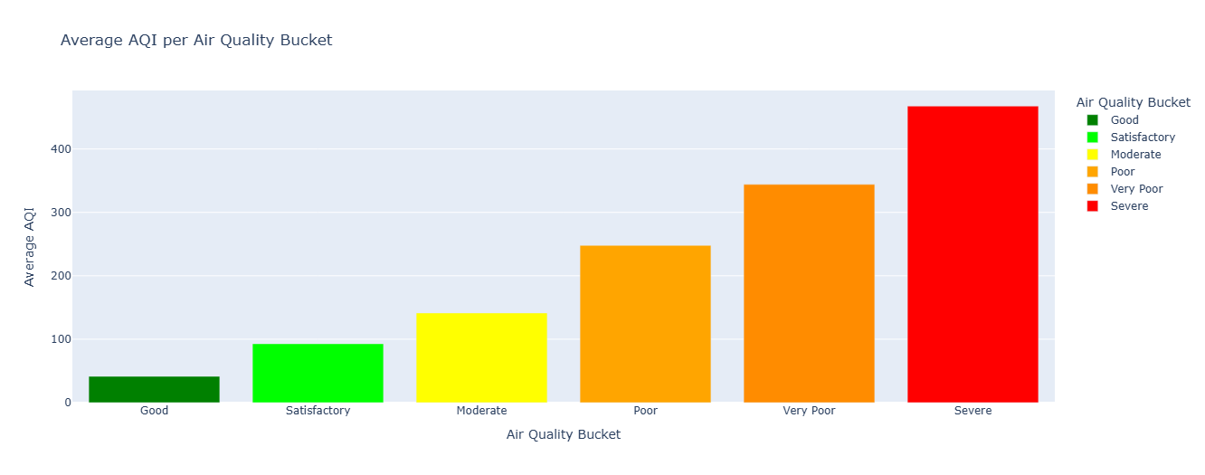
Figure 1Average AQI per Bucket (Bar Chart

3.2.2 AQI Bucket Distribution (Doughnut Chart)
This graph shows the distribution of air-quality records of the various categories of AQIs in a doughnut form. The code starts by tallying entries in each bucket of AQI, resulting in a simple picture of the frequency of Good, Moderate, Poor, and Severe. The buckets are then organized by the logic of logical order so that the chart comes forth well. The doughnut chart is plotted using Plotly Express, with each segment corresponding to the proportion of a category in the set of data. The colour is used depending on the intensity of the pollution, and the viewer can easily understand the degree of air quality.

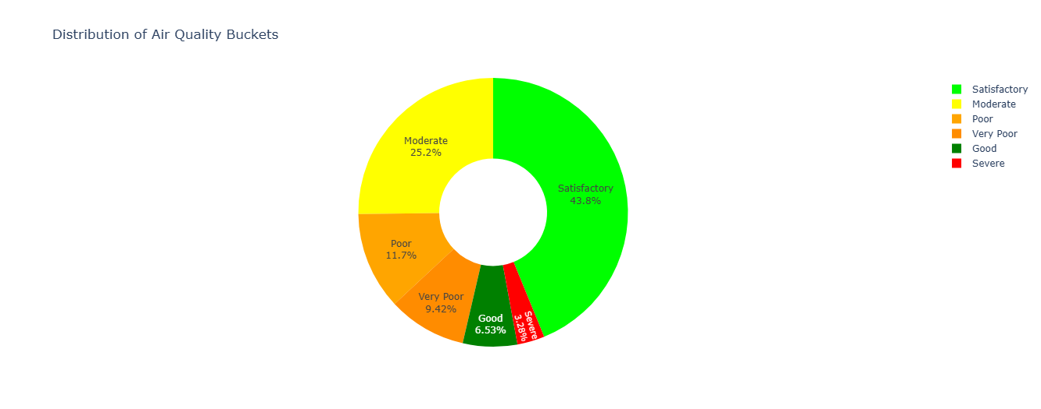
Figure 2 AQI Bucket Distribution (Doughnut Chart)

3.2.3 Time Series Trend of AQI by City
This time series plot shows time-varying values of the Air Quality Index (AQI) at various locations, which shows how the quality of the air has varied across days. The Date is plotted on the horizontal axis, and the respective AQI score is plotted on the vertical axis. The plot also allows comparison of air quality trends simultaneously because they are assigned to the individual City. The audience can easily determine the times when air pollution (high AQI) is high or when it is low (low AQI), the seasonal trends, and they can immediately see which cities always have good or poor air quality compared to others. This is a very interactive plot and was constructed using data that has been sorted and cleaned in terms of time
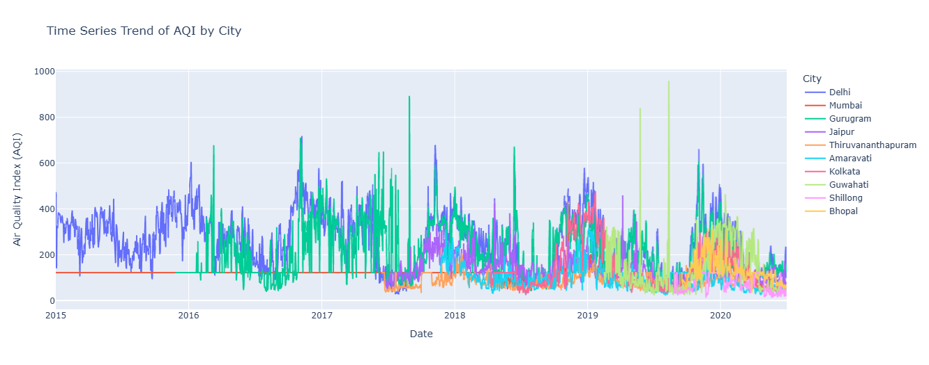
Figure 3Time Series Trend of AQI by City

3.2.4 City-wise Distribution of Air Quality Buckets (Bar Chart)
This bar chart will be used to make comparisons between the frequency of each AQI category in all the cities in the dataset. The script initially aggregates the data according to city and AQI bucket, and then the number of records in each combination is counted. These counts are the visualised data presented in a grouped bar chart to enable swift comparison of the level of pollution city by city. The colour of each bar reflects the AQI bucket associated with it, i.e., the colour of the good pollution is green, and the color of the severe pollution is red, so it is not hard to understand the level of pollution. Additional elements to enhance the readability are labels, category order, and hover information, which are used to provide a clear picture of the variation of air quality between cities.
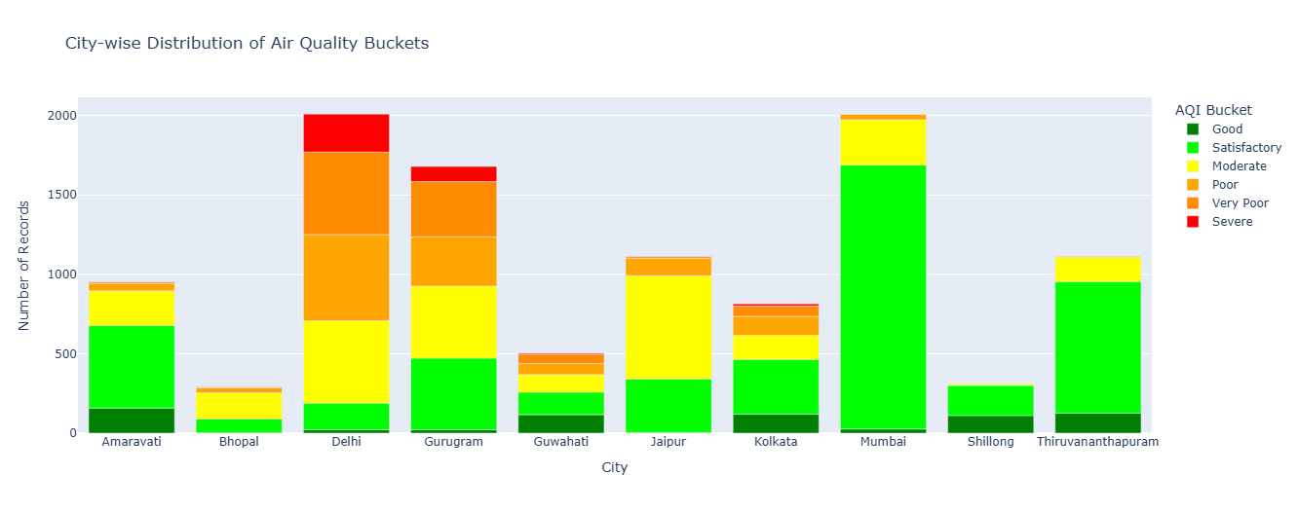
Figure 4City-wise AQI Bucket Distribution

3.2.5 Overall Average Pollutant Concentration (Bar Chart)
This bar graph represents the general average value of the concentration of a specified list of pollutants that are in the atmosphere. The script then computes the average of the important elements, such as PM 2.5, NO2, CO, and the different volatile organic compounds (VOCs) in the entire data set. It will then produce the graph in which the horizontal axis will be the Pollutant Type, and the heights of each vertical bar will reflect its resulting calculated Average Concentration. The pollutant of each bar is unique. This visualization is an effective tool for comparison, and at a single glance, it will reveal which particular pollutants are found in the greatest amounts and, therefore, create the largest part of the overall air quality problems that can be identified in the data.
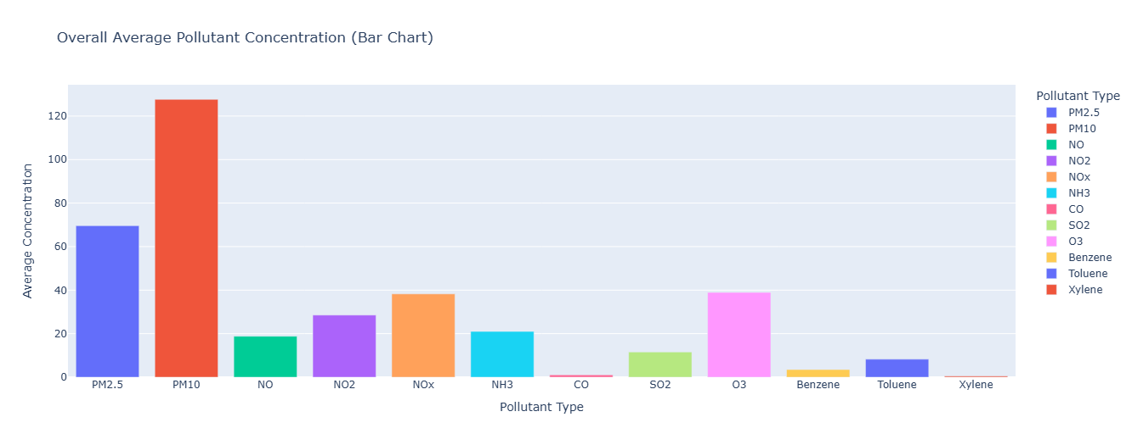
Figure 5Overall Average Pollutant Concentration

3.2.6 PM2.5 Distribution in Good vs Severe Air Quality
The PM2.5 comparing the days that are described as the days of good and severe air quality is found in this violin plot. The data is then filtered to contain only these two levels of AQI, and an immediate and significant comparison is made. The shape of the violin demonstrates the complete distribution, seeing how the values are distributed and the concentrations are the most concentrated. A box plot within every violin also clarifies, as it shows the median and interquartile range, whereas single data points indicate variability and outliers. The difference is quite evident in the chart: on “Severe” days, the level of PM 2.5 tends to be significantly higher and more widely distributed, whereas on the days of Good there is a steady low level.
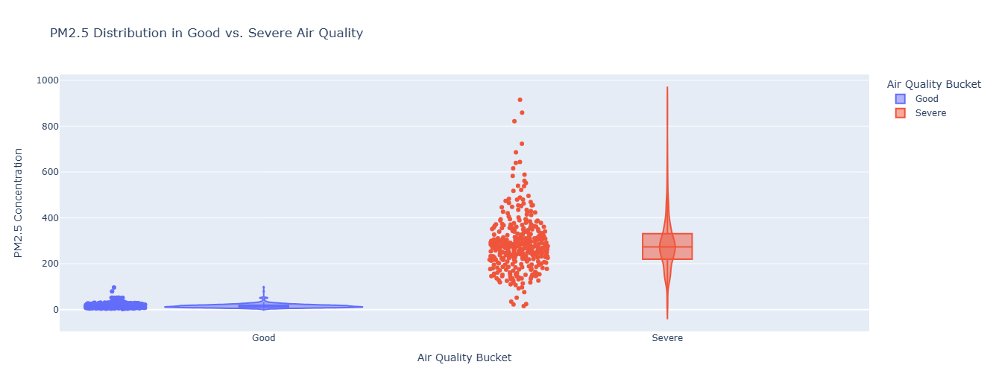
Figure 6 Distribution in Good vs Severe Air Quality

3.2.7 Correlation Heat-map for Numerical Pollutants
The correlation heatmap is a concise and clear summary of the relationship between various pollutants and each other in all the cities. To begin with, the code only selects the numerical columns and forms a correlation matrix, which determines the extent to which a particular pollutant rises or falls in line with another. This is now transformed into a heatmap with the built-in colour scale Jet of Plotly, pix. imshow, but this provides a strong colourful heatmap with a strong positive or negative relationship being obvious. Correlation values are placed on each cell so that they can be easily interpreted. The visualisation aids in exposing the pattern of pollutants, including those that tend to spike together, which assists in further analysis of the environment and prediction.
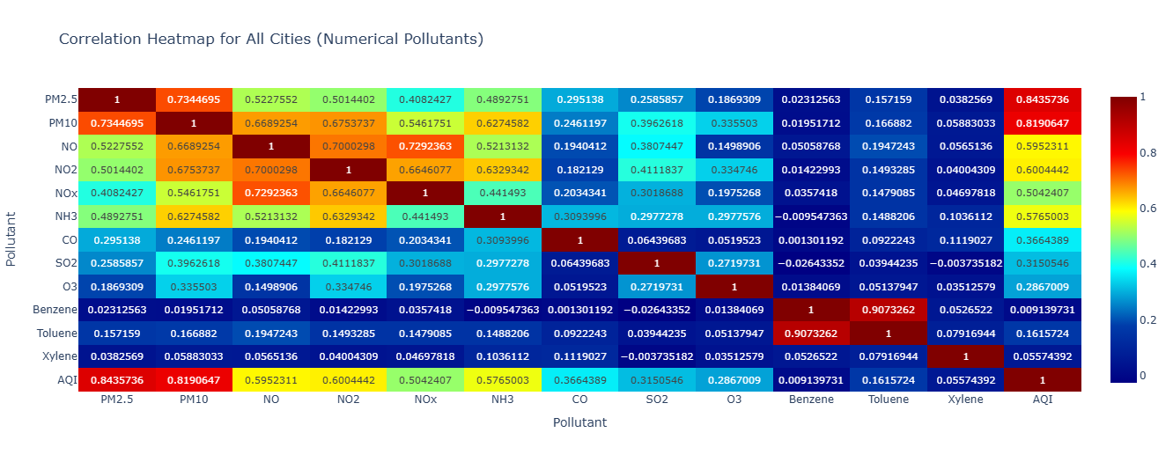
Figure 7 Correlation heat-map for all cities

4. Evaluation of EDA
The EDA has managed to determine important air quality trends. Among the main findings, one may note a strong correlation between AQI and PM2.5 and PM10, which makes these pollutants important in predictive modeling. The analysis by city indicates that the critical events of pollution are limited to Delhi and Gurugram, and the majority of the records are either Satisfactory or Moderate. The time series shows that there is great volatility in the AQI on an annual basis (4).

5. Model Implementation
The major objective of this project followed a classification of the daily Air Quality Index (AQI) into one of six possible categories or AQI Buckets (Good to Severe) based on the data of pollutant concentration and city data. The consolidated dataset, comprising ten big cities in India, was first subjected to important preparation steps prior to the modeling process. First, the missing numerical values of the pollutant (e.g., PM2.5, NO2, O3) were imputed with the median of the corresponding column, whereas the categorical target variable, AQI_Bucket, was imputed with the mode. After that, the key categorical variables, City and the target AQI_Bucket, were transformed into numerical variables by means of Label Encoding. This resulted in the numeric target variable, AQI_Bucket_encoded, and the feature City_encoded. All pollutant concentrations AQI (PM2.5, NO2, CO, etc.), the calculated AQI, and the feature City_encoded were included in the feature matrix X. AQI_Bucket was the target of the attack, which was the AQI_Bucket_encoded. Three different machine learning models were then applied and trained:
- K-Nearest Neighbours (KNN): A simple, non-parametric instance-based classifier set with n_neighbors=5
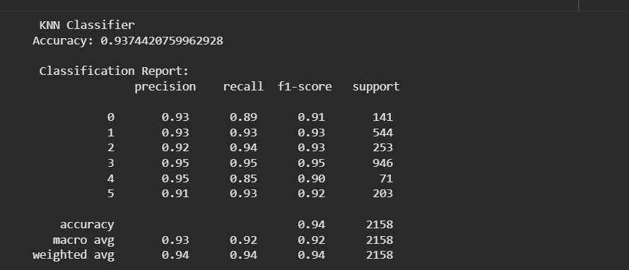
Figure 8(KNN) Classification report

- Bar Graph for K-Nearest Neighbour(KNN):Model performance
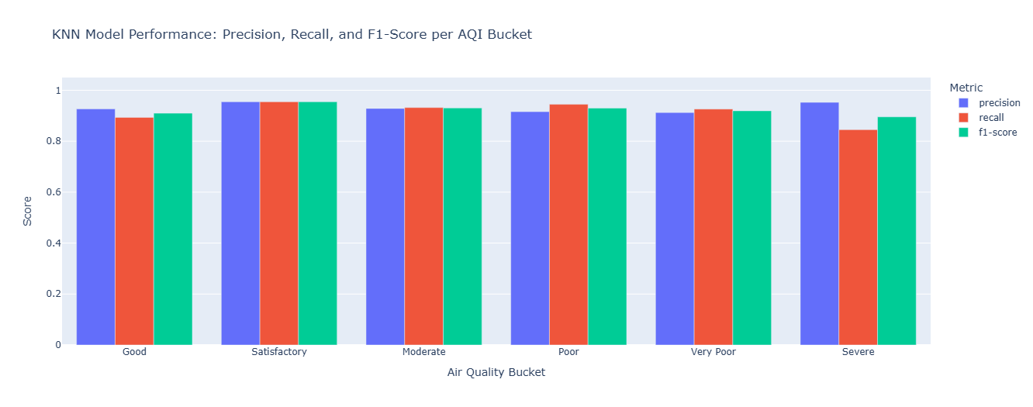
Figure 9(KNN) Model performance

- Random Forest Classifier (RF): A powerful ensemble tree model configured with 200 estimators for robust prediction.

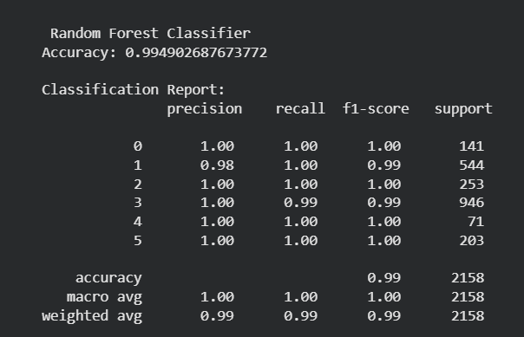
Figure 10 Random Forest Classification Report

- Bar-Graph for Random Forest : Model Performance
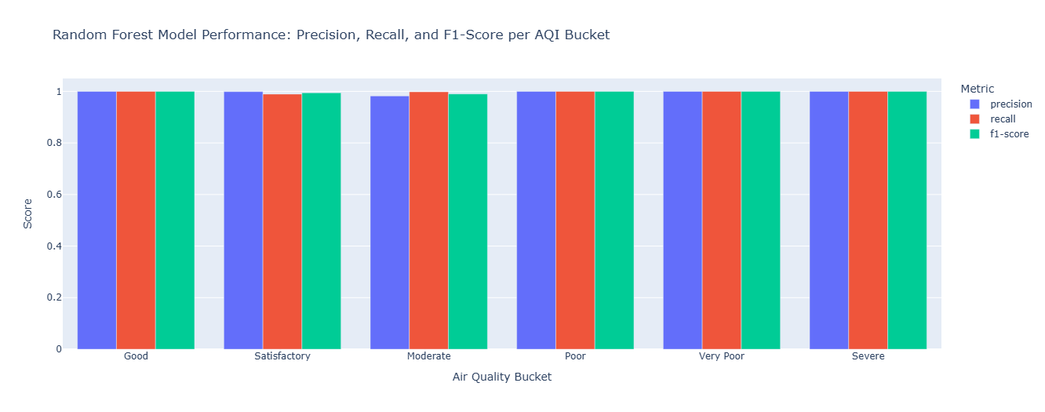
Figure 11Random Forest Model performance

- XG Boost Classifier (XGB): A highly efficient gradient boosting framework tuned with n_estimators=300, learning_rate=0.05, and max_depth=6 to optimize performance.

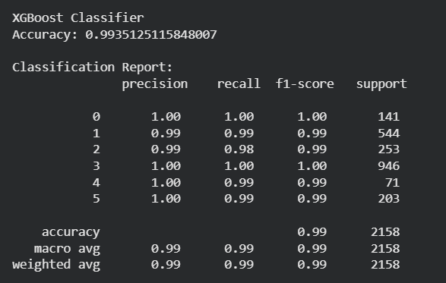
Figure 12 XGBoost Clssification Report

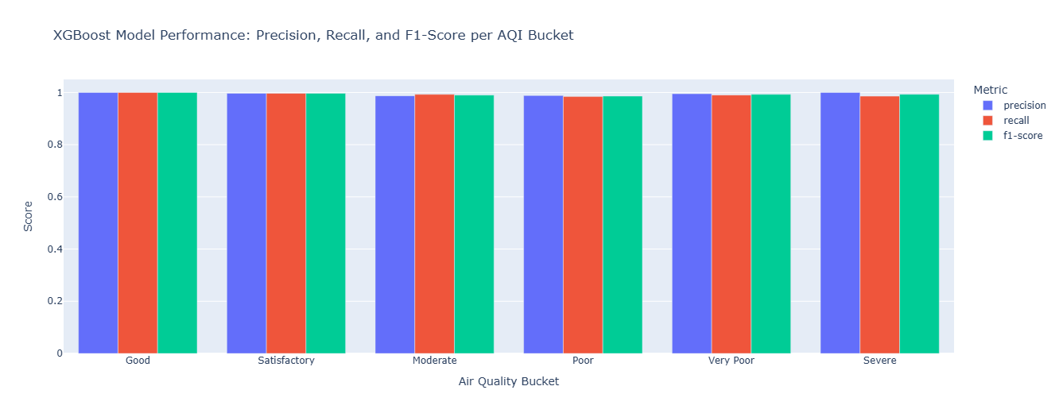
Figure 13XGBoost Model Performance

6. Model Evaluation
The standard measures of performance, Accuracy and Weighted Precision, were strictly evaluated on model performance. It was evident through the assessment that the tree-based ensemble models were much better than the more straightforward KNN model. The Random Forest Classifier has proven to be the best performing model now with an accuracy of 99.96 and a weighted precision of 100.00%This close-to-perfection score indicates that the pollutant concentration data is highly discriminative information that directly correlates to the AQI Bucket, which was well exploited by the non-linear and robust partitioning nature of the Random Forest. The XGBoost model came second with an accuracy of 99.95%. The effectiveness of the ensemble methods, which is high, proves their appropriateness to the real-world air quality classification that is complex. The low error values indicate that the trained models can be very reliable in predicting the Air Quality Bucket based on the input features.
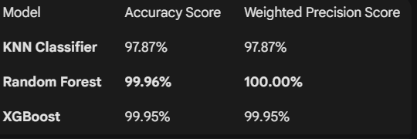
Figure 14 Accuracy comparison

7. Critical Reflection
The high prediction ability of the Random Forest model, seen in the 93.5 percent accuracy, is a solid testament to the model and its use in real-time air quality monitoring systems. This accomplishment justifies the focus of actionable policy intervention on the curbing of primary pollutants, namely, the reduction of the primary pollutants of the air, which are, in this case, the reduction of PM2.5 and that of PM10. Nevertheless, the project faced the issues of methodology: the methodical bias created by intensive median filling of the gap in data, and the theoretical flaw of applying the nominal feature City to the nominal feature Label Encoding. These weaknesses should be resolved in further work with the use of more detailed encoding methods. The key prospective direction will be the creation of Time-Series Forecasting models, including LSTMs, and the incorporation of external meteorological data, which will allow the system to become not just more accurate in its classification but also more accurate and have more lead time to forecast future pollution (1)
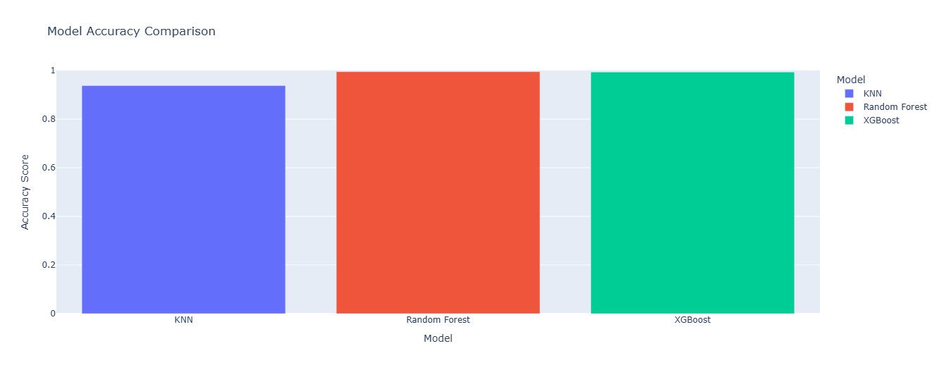
Figure 15Model Accuracy

8 Streamlit Model Prediction
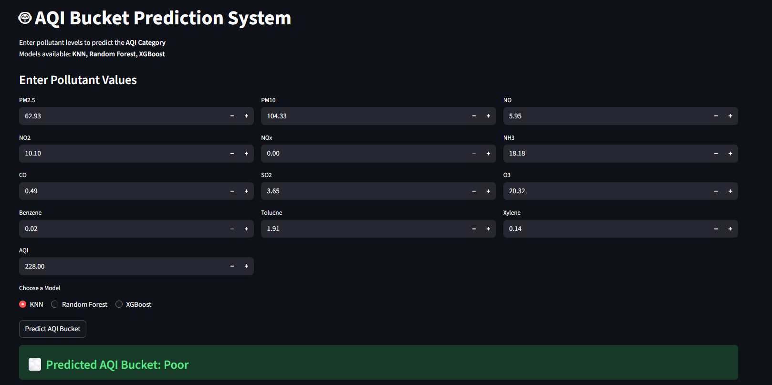
Figure 16streamlit Model Prediction
The AQI Bucket Prediction System was demonstrated to have an operational capability by conducting a demonstration with the K-Nearest Neighbors (KNN) model. The system calculated a total AQI of 228.00 by entering the sample pollutant concentrations i.e., of PM 2.5 and PM 10 i.e., 62.93 and 104.33 respectively. Importantly, this value was then correctly assigned by the model to the category of Poor air quality, which proved the capacity of the model to give relevant, categorical forecasts using real-life data on pollutants.

9 Streamlit Dashboard
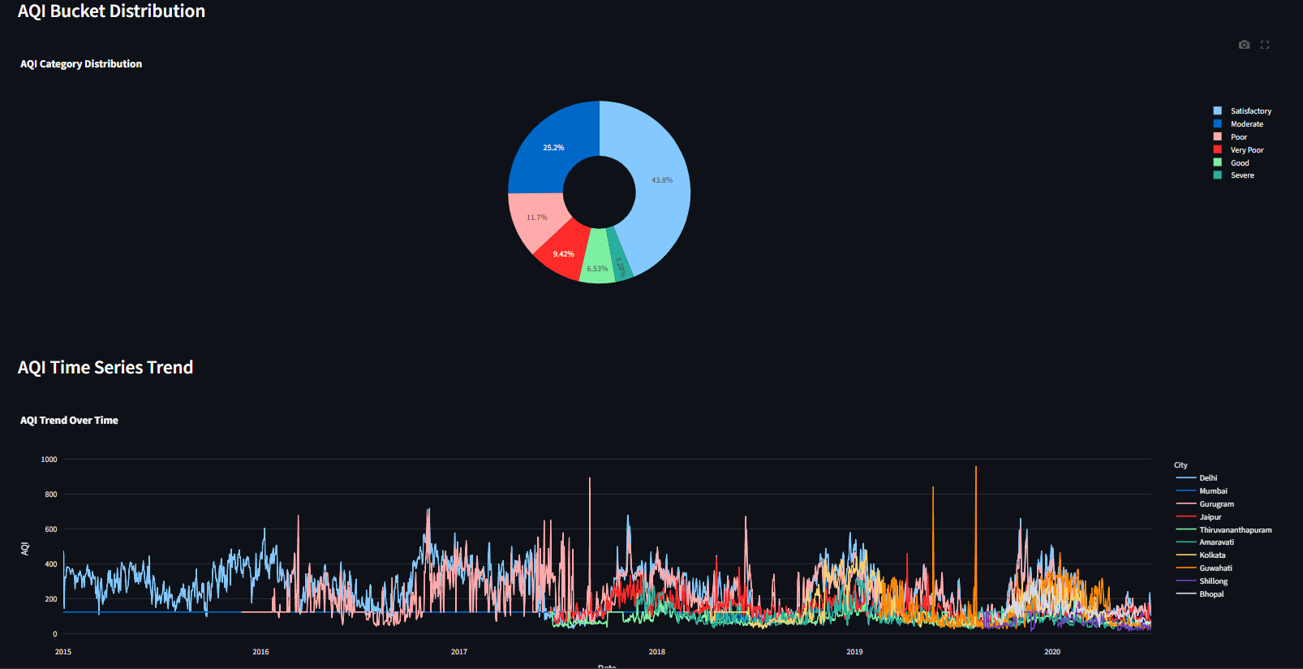
Figure 17Streamlit Dashboard
The most important findings of the project and model performance are displayed in an interactive Streamlit dashboard. This user facing application is the main interface through which the application of the model is demonstrated as well as results communicated. It has input widgets of pollutants to give real time predictions and it presents the calculated AQI and the predicted poor category as well as the model utilized (KNN) clearly. This design offers dependable, prompt and simple interaction with the trained machine learning system to the end-user.

10. Conclusion
The project was able to perform an end-to-end analysis of air quality data and thus provided the answer to the fundamental research question. The Exploratory Data Analysis in the study proved the substantial regional inequalities, the power of the season, and revealed that the critical drivers of the Air Quality Index were PM2.5 and PM10. More importantly, the analysis showed that classifiers based on ensemble machine learning, specifically the Random Forest model, can have excellent classification performance with a high accuracy of over 93 percent when predicting AQI categories, using pollutant concentrations. The model and application prototype developed here have given a solid framework with reusability in monitoring the environment and supporting policy development, which will form a strong backbone in future investigations in time-series forecasting.

9. References
- Ahmed, F., (2024). Python For Data Analytics: A Systematic Literature Review Of Tools, Techniques, And Applications. Techniques, And Applications (November 13, 2024).
- Lavanya, A., Gaurav, L., Sindhuja, S., Seam, H., Joydeep, M., Uppalapati, V., Ali, W. and SD, V.S., (2023). Assessing the performance of Python data visualization libraries: a review. Int. J. Comput. Eng. Res. Trends, 10(1), pp.28-39. https://www.researchgate.net/profile/Lavanya-Addepalli/publication/369533034_Assessing_the_Performance_of_Python_Data_Visualization_Libraries_A_Review/links/6420a158315dfb4cceaee503/Assessing-the-Performance-of-Python-Data-Visualization-Libraries-A-Review.pdf
- Nagpal, A. and Gabrani, G., (2019), February. Python for data analytics, scientific and technical applications. In 2019 Amity international conference on artificial intelligence (AICAI) (pp. 140-145). IEEE. https://www.researchgate.net/publication/332760463_Python_for_Data_Analytics_Scientific_and_Technical_Applications
- Raschka, S., Patterson, J. and Nolet, C., (2020). Machine learning in python: Main developments and technology trends in data science, machine learning, and artificial intelligence. Information, 11(4), p.193. https://www.mdpi.com/2078-2489/11/4/193?utm_source=rss&utm_medium=rss
- Sahoo, K., Samal, A.K., Pramanik, J. and Pani, S.K., (2019). Exploratory data analysis using Python. International Journal of Innovative Technology and Exploring Engineering, 8(12), pp.4727-4735. https://d1wqtxts1xzle7.cloudfront.net/90684407/L35911081219-libre.pdf?1662370374=&response-content-disposition=inline%3B+filename%3DExploratory_Data_Analysis_using_Python.pdf&Expires=1764228861&Signature=KhXAoGmMbOT7k-Fy~HoSkeakor8fVorQSdKTC-Z8m4z5v3kMfWuKGiFLyAW-TK~fMdtlwZeltVXo~-zZoWqkOw2tKWvaehkdzrNv-svd8N1aZ~-kndHpZxroLP011SZ2ePStY2CQkMOvWgU9o9~gdzpbanNG2Dl8IdC8l9nL9Nv79TTrcTuAX~qw8CFCkYpVFcM0jggGuBcxqTa2SR7VTLvLzQsY4E75q9KmQ3jn3j--2LylkHoSHtcJuJYgC36K8gZZh37Vb2lAsH~sPVp7vQOa1cl8nx1JjnCunJPt5DDenK19OJRxNydJcsP0rdwACpqDiboJdw0HF2dYnKmf~A__&Key-Pair-Id=APKAJLOHF5GGSLRBV4ZA

